TASK 1:
//22k-4080

#include <iostream>
using namespace std;

int Funct(int n){

if(n <= 1){
return n;
}
else{
return Funct(n-1) + Funct(n-2);
}
}

int main(){
int n ;
cout<< "how many terms you want?" << endl;
cin >> n;
cout << "Fibonacci Series: " << endl;

for(int i = 0; i<=n;i++){
cout << Funct(i) << ", ";
}

return 0;
}
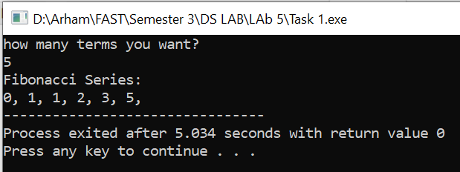

TASK 2:
// 22k-4080
#include <iostream>
using namespace std;

int indirectRecFun1(int n){

if(n>-1 && n <= 1){
return n;
}
else{
return indirectRecFun1(n-1) + indirectRecFun1(n-2);
}
}

int indirectRecFun2(int n){

return indirectRecFun1(n);
}

int main(){
int n ;
cout<< "how many terms you want? (term starts from 0)" << endl;
cin >> n;
cout << "Fibonacci Series: " << endl;

for(int i = 0; i<=n;i++){
cout << indirectRecFun2(i) << ", ";
}
cout<<endl;
cout<< "Indirect Approach Succesful!!";
return 0;
}
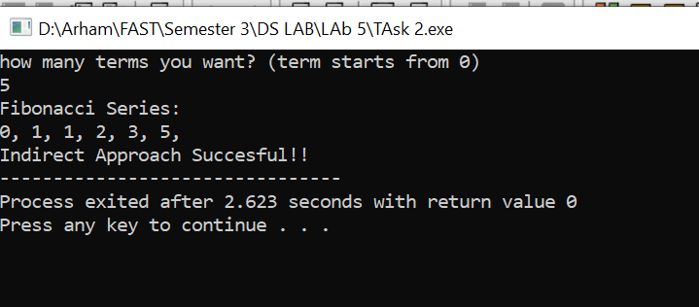
TASK 3:
//22k-4080

#include <iostream>
using namespace std;
void bubbleSortPass(int arr[], int n) {

for(int i = 0; i < n-1; i++){

for (int j = 0; j < n - i - 1; j++) {

if (arr[j] > arr[j + 1]) {
swap(arr[j], arr[j + 1]);
}
}
}
}

// I have used indirect recursion for my own clarification
void tailedrecursiveBubbleSort(int arr[], int n) {
if (n <= 1)
return; // If the array has 1 or 0 elements, it's already sorted

bubbleSortPass(arr, n);
tailedrecursiveBubbleSort(arr, n - 1);
}

void nonTailedrecursiveBubbleSort(int arr[], int n){
if(n <= 1)
return;

bubbleSortPass(arr,n);
nonTailedrecursiveBubbleSort(arr, n-1);
cout<<"\n"<<endl;
}

int main() {
int arr[] = {60, 37, 29, 112, 22, 11, 90};
int n = sizeof(arr) / sizeof(arr[0]);

int arr2[] = {60, 37, 29, 112, 22, 11, 20};
int n2 = sizeof(arr) / sizeof(arr[0]);

cout << "Unsorted Array: ";
for (int i = 0; i < n; i++) {
cout << arr[i] << " ";
}

tailedrecursiveBubbleSort(arr, n);

cout << "\nSorted Array: ";
for (int i = 0; i < n; i++) {
cout << arr[i] << " ";
}
cout<<endl;

cout<< "Unsorted Array 2 for Non-Tailed: ";

for (int i = 0; i < n; i++) {
cout << arr[i] << " ";
}

nonTailedrecursiveBubbleSort(arr2, n2);

cout << "\nSorted Array: ";
for (int i = 0; i < n; i++) {
cout << arr[i] << " ";
}
cout<<endl;

return 0;
}
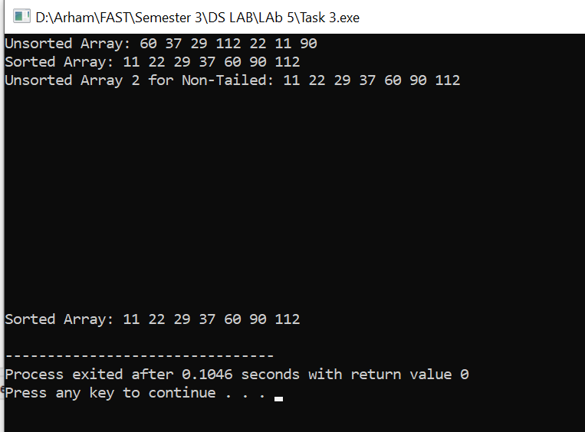

TASK 4:
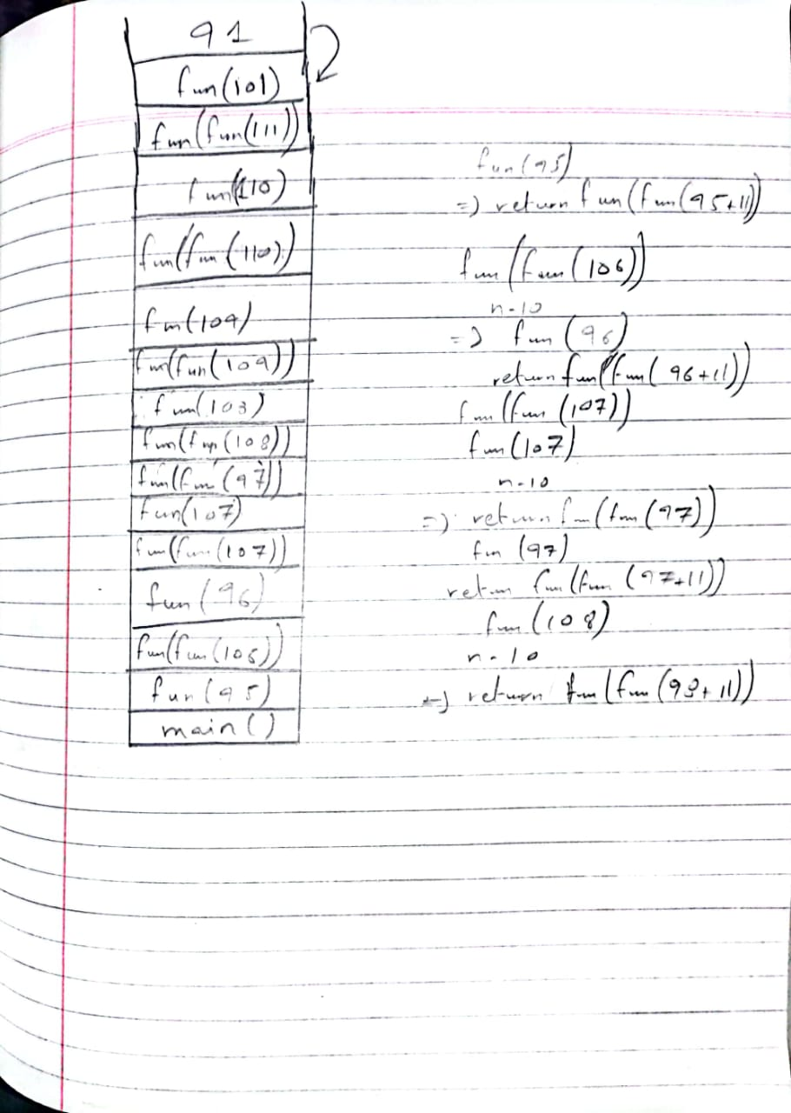

TASK 5:
To be submitted in Lab 6.

